Git –version

Git config –global user.name “ramesh”

Git config –global user.name “ramesh@gmail”

Git config –global user.password “dfgftghfthrthrtyhtyhty” **🡸==== Add Token** Instead

Just to view the entries use :- git config –list

*Git config –global –unset credential.helper*

-----------------------------------------------------------------------------------------------------------------------------------------------------

C:\Users\ashis\OneDrive\Desktop\Infogain Batch\AugBCT_Workspace\JSPDemoApp1> **git init**

Initialized empty Git repository in C:/Users/ashis/OneDrive/Desktop/Infogain Batch/AugBCT_Workspace/JSPDemoApp1/.git/

C:\Users\ashis\OneDrive\Desktop\Infogain Batch\AugBCT_Workspace\JSPDemoApp1>**git status**

C:\Users\ashis\OneDrive\Desktop\Infogain Batch\AugBCT_Workspace\JSPDemoApp1>**git add -A**

C:\Users\ashis\OneDrive\Desktop\Infogain Batch\AugBCT_Workspace\JSPDemoApp1>**git status**

On branch master

C:\Users\ashis\OneDrive\Desktop\Infogain Batch\AugBCT_Workspace\JSPDemoApp1>  
 **git commit -m "test commit jsp app"**

C:\Users\ashis\OneDrive\Desktop\Infogain Batch\AugBCT_Workspace\JSPDemoApp1>**git status**

On branch master , nothing to commit, working tree clean

*Now let’s think u want to undo the changes and want to retrieve previous changes, use Git Checkout command*

C:\Users\ashis\.. >**git checkout abc.txt ,** *Note file name after checkout is mandatory*

git diff :- gives information regarding git file change

**Git log**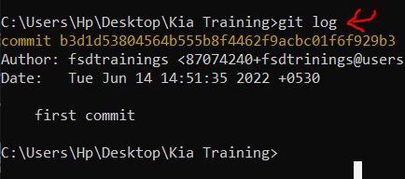

**Git log –p -2 // *gives last 2 logs***

*Note :- commit is mandatory to have logs*

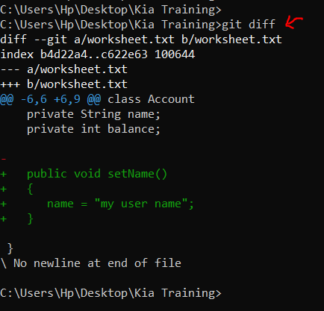

***Delete File***

*Remove file from staging area only, but u want to keep in the memory*

*rm –cached abc.txt*

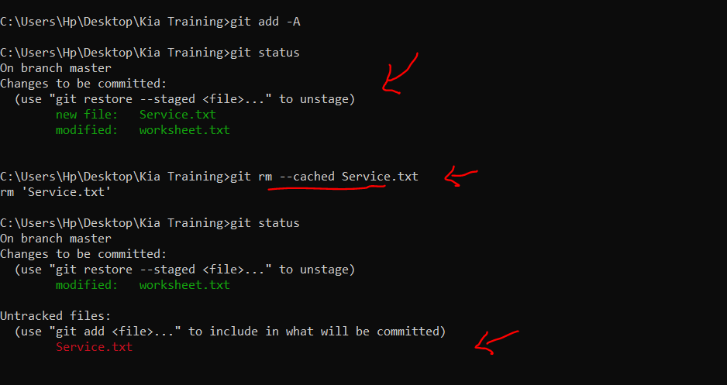

Branching things

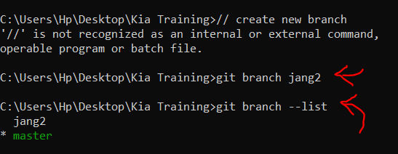Create new Branch

Switch to new branch

***Git checkout <branch-name>***

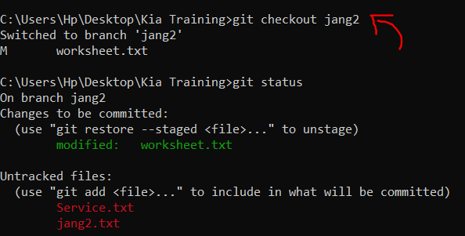

Branch merging

After committing a task on the new branch it’s time to merge your task with the master branch, so for that we should checkout to master branch first

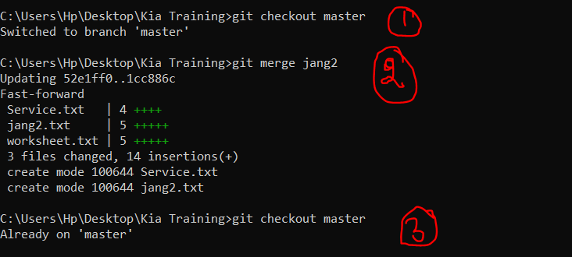

Now delete the unused branch : git branch –d <branch-name>

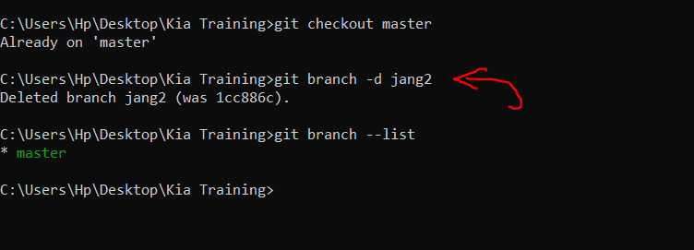

=========== Now to Add in the remote repository ==============

1. **Create Repository**

C:\Users\ashis\OneDrive\Desktop\Infogain Batch\AugBCT_Workspace\JSPDemoApp1>**git remote add origin** https://github.com/fsdtrinings/testrepoinfogain.git

C:\Users\ashis\OneDrive\Desktop\Infogain Batch\AugBCT_Workspace\JSPDemoApp1>**git remote**

origin

C:\Users\ashis\OneDrive\Desktop\Infogain Batch\AugBCT_Workspace\JSPDemoApp1>**git push origin master**

Enumerating objects: 68, done.

Counting objects: 100% (68/68), done.

Delta compression using up to 8 threads

Compressing objects: 100% (58/58), done.

Writing objects: 100% (68/68), 26.77 KiB | 1.27 MiB/s, done.

Total 68 (delta 5), reused 0 (delta 0), pack-reused 0

remote: Resolving deltas: 100% (5/5), done.

To https://github.com/fsdtrinings/testrepoinfogain.git

* [new branch] master -> master

C:\Users\ashis\OneDrive\Desktop\Infogain Batch\AugBCT_Workspace\JSPDemoApp1>

**Pull / clone repository from remote**

D:>officeTask> git init

:/> git pull <url> <branch-name>

Calling Other Team Members

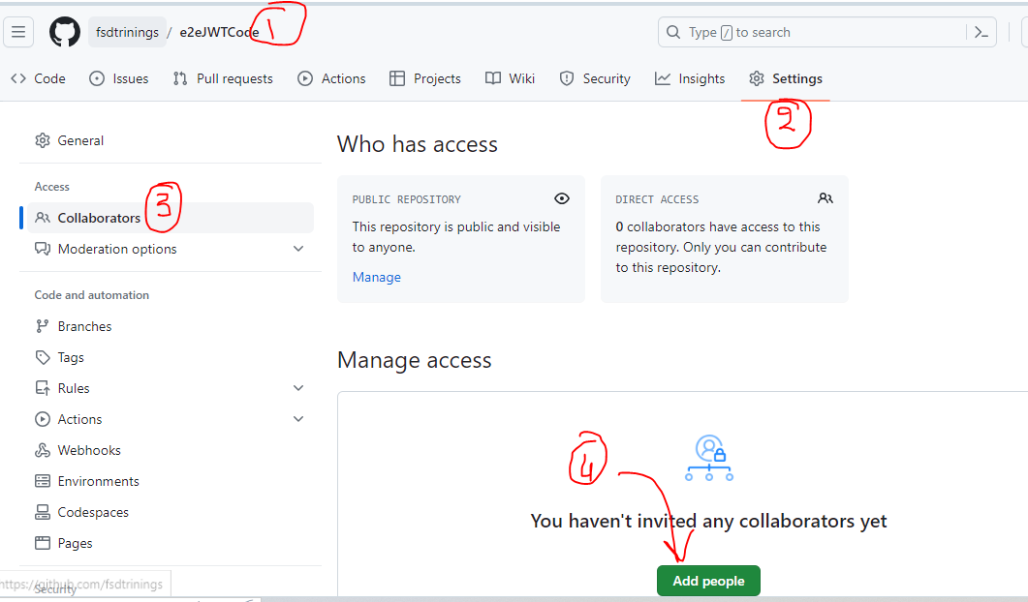

Accepting Request to collaborate

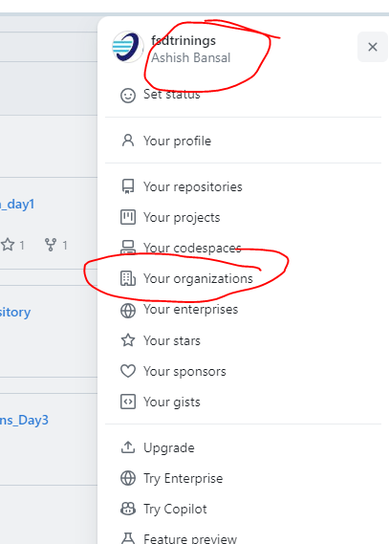

Click on Join